**Heading:**

Document Name: Sprint 1 Plan

Product Name: SlugPath

Team: Slugstras

Sprint Completion Date: February 2, 2018

Revision 1.3 (2-7-18)

**Goal:**

Complete our “slugstra” algorithm to find the most optimal shortest walking path to take between two locations.

**Task Listing:**

* User Story 1: As a javascript developer, I need to develop the shortest path algorithm so that we can display the shortest path on a visualized map.

User Story 1 Tasks

1. Learn and develop A* algorithm
2. Code Node and Graph objects
3. Develop usable dropdown menu to select locations

* User Story 2: As a data manager, I want node and edge data so that I can organize our data efficiently.

User Story 2 Tasks

1. Learn how to make a viable database structure
2. Create all database objects by node and edge classification
3. Collect location data

* User Story 3: As a user, I want to see the path so that I know where I am going.

User Story 3 Tasks

1. Create the visual map through Leaflet

**Team Roles:**

Joven Pableo: Product Owner and Developer

Edward John Tagaca: Initial Scrum Master and Developer

Cameron Skaggs: Data Management and Developer

Pranav Salunk: Developer

Srijitha Somangili: Developer

**Initial Task Assignment:**

Joven Pableo: User Story 1: Code Node and Graph objects

Edward John Tagaca: User Story 3: Create the visual map through Leaflet

Cameron Skaggs: User Story 2: Learn how to make a viable database structure, Collect location data

Pranav Salunk: User Story 1: Learn and develop A* algorithm

Srijitha Somangili: User Story 1: Develop usable dropdown menu to select locations

**Initial Burnup Chart:**

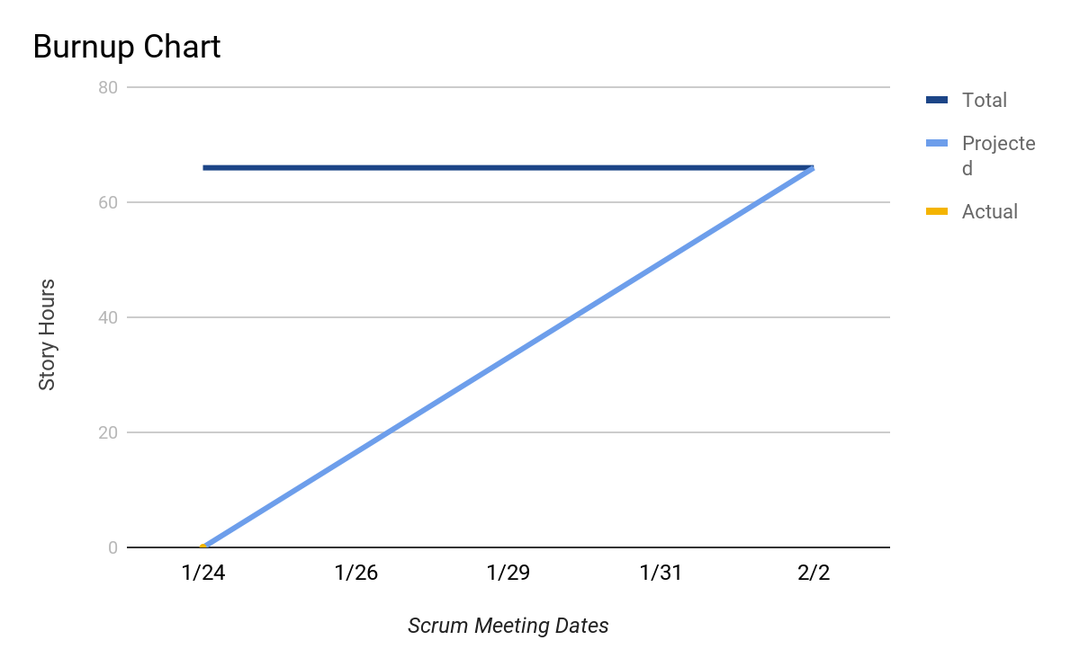

**Initial Scrum Board:**

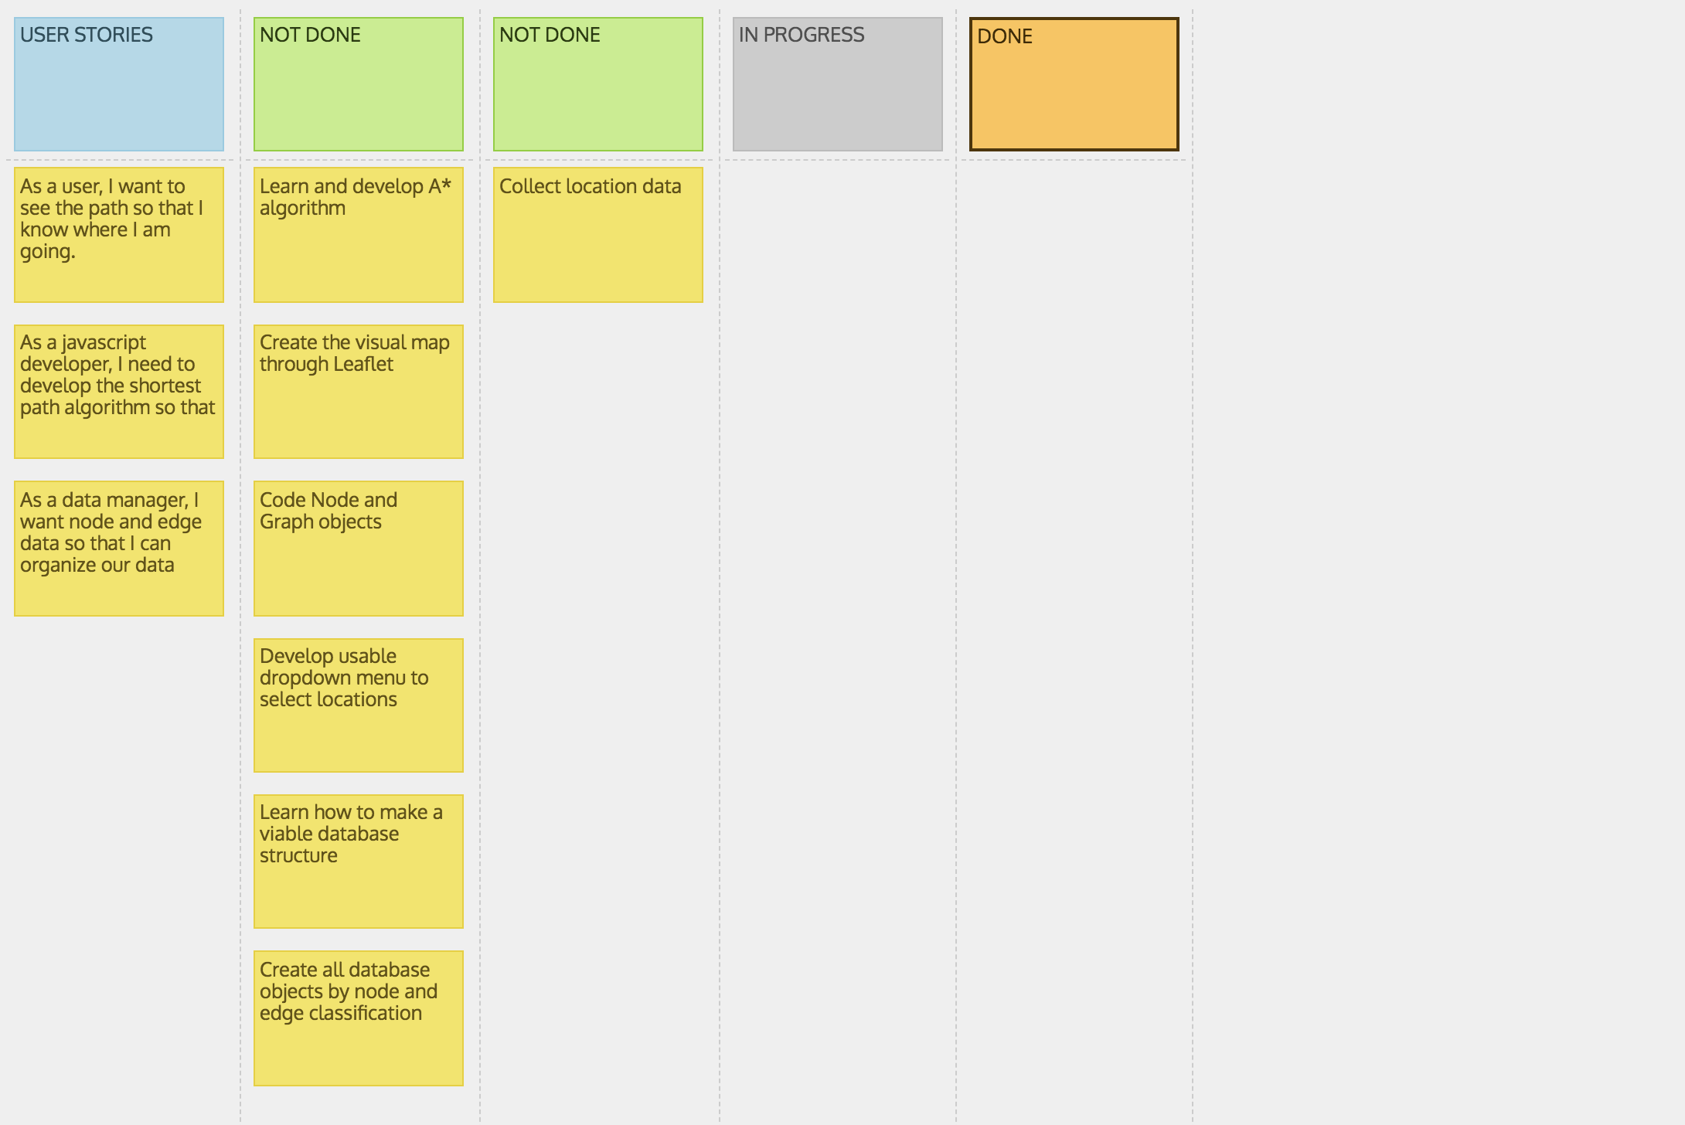

**Scrum Times:**

Monday: 12:00 PM - 12:15 PM

Wednesday: 12:00 PM - 12:15 PM (Scheduled TA visit)

Friday: 12:00 PM - 12:15 PM